LAB PROGRAM :

import java.util.*;

class book

{

String name,author;

int price,num_pages;

book(String nam,String a,int p,int no)

{

name=nam;

author=a;

price=p;

num_pages=no;

}

static String accept_name()

{

Scanner sc=new Scanner(System.in);

System.out.println("enter name of the book");

return(sc.nextLine());

}

static String accept_author()

{

Scanner sc=new Scanner(System.in);

System.out.println("enter name of the author");

return(sc.nextLine());

}

static int accept_price()

{

Scanner sc=new Scanner(System.in);

System.out.println("enter price of the book");

return(sc.nextInt());

}

static int accept_pages()

{

Scanner sc=new Scanner(System.in);

System.out.println("enter no of pages of the book");

return(sc.nextInt());

}

public String toString()

{

return("name : "+name+"\n author : "+author+"\n price : "+price+"\n no of pages : "+num_pages);

}

public static void main(String args[])

{

Scanner sc=new Scanner(System.in);

int n;

System.out.println("enter value of n");

n=sc.nextInt();

String nam,a;

int p,no;

book []obj=new book[n];

for(int i=0;i<n;i++)

{

nam=accept_name();

a=accept_author();

p=accept_price();

no=accept_pages();

obj[i]=new book(nam,a,p,no);

}

int x=1;

for(int i=0;i<n;i++)

{

System.out.println("BOOK "+(x++));

System.out.println(obj[i]);

}

}

}

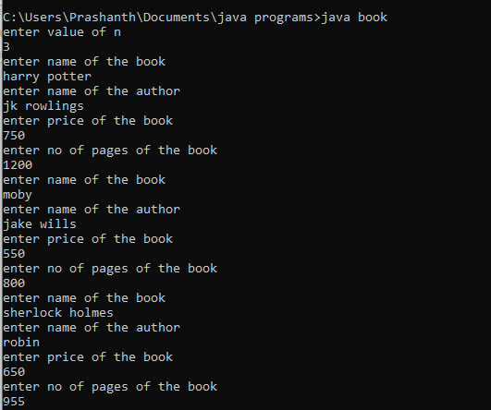

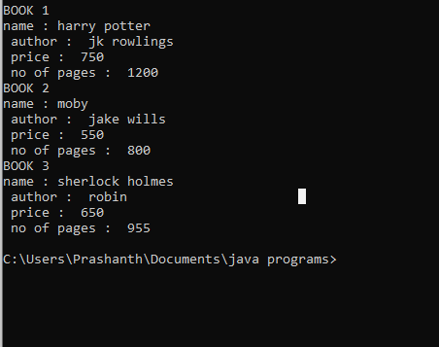

EXTRA PROGRAM 1:

import java.util.*;

class employee

{

String empid,empname;

int empnohrs;

double empbasic,emphre,empda,empit,empgross;

void accept()

{

Scanner sc=new Scanner(System.in);

empid=sc.nextLine();

System.out.println("enter name");

empname=sc.nextLine();

System.out.println("enter no of hours");

empnohrs=sc.nextInt();

System.out.println("enter basic salary hre da and it in percentage");

empbasic=sc.nextDouble();

emphre=sc.nextDouble();

empda=sc.nextDouble();

empit=sc.nextDouble();

}

void calculate()

{

double extra=0.0;

empgross=empbasic+empbasic*emphre+empbasic*emphre-empbasic*empit;

if(empnohrs>200)

extra=(empnohrs-200)*100;

if(empnohrs<200)

extra=-(200-empnohrs)*100;

System.out.println(" gross salary : "+empgross);

empgross=empgross+extra;

if(extra==0.0)

System.out.println("no change in salary after considering no of hours of work \n final salary : "+empgross);

else if(extra>0.0)

{

System.out.println("overtime amount : "+extra);

System.out.println("final salary : "+empgross);

}

else

{

System.out.println("salary reduced : "+extra);

System.out.println("final salary : "+empgross);

}

}

public static void main(String args[])

{

employee obj=new employee();

obj.accept();

obj.calculate();

}

}

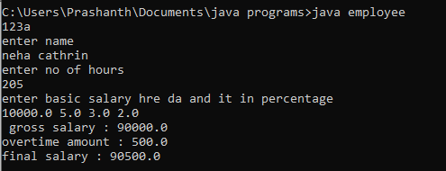

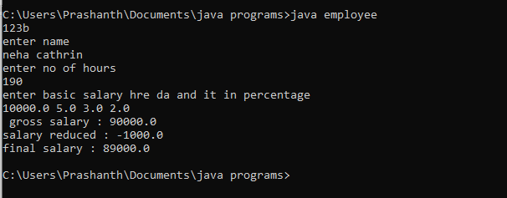

EXTRA PROGRAM 2:

import java.util.*;

class age

{

int years,months;

public static void main(String args[])

{

Scanner sc =new Scanner(System.in);

age age1=new age();

age age2=new age();

System.out.println("enter age of jack");

age1.years=sc.nextInt();

age1.months=sc.nextInt();

System.out.println("enter age of jill");

age2.years=sc.nextInt();

age2.months=sc.nextInt();

System.out.println("elder person:");

if(age1.years>age2.years)

System.out.println("jack");

else if(age1.years==age2.years)

{

if(age1.months>age2.months)

System.out.println("jack");

else if(age1.months==age2.months)

System.out.println("both are of same age");

else

System.out.println("jill");

}

else

System.out.println("jill");

}

}

